eesy-form

Simulation for bulk metal forming

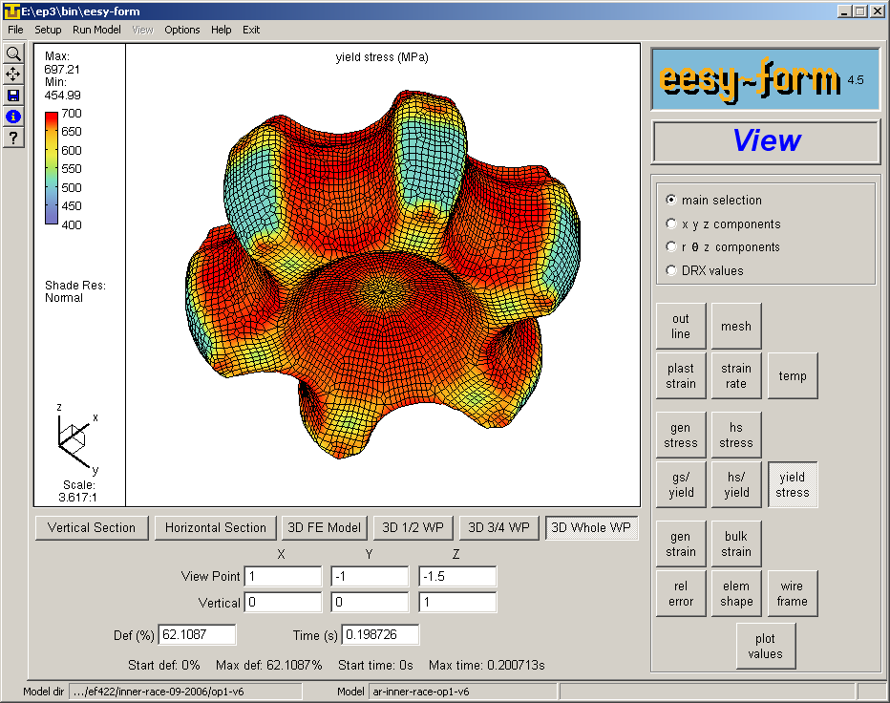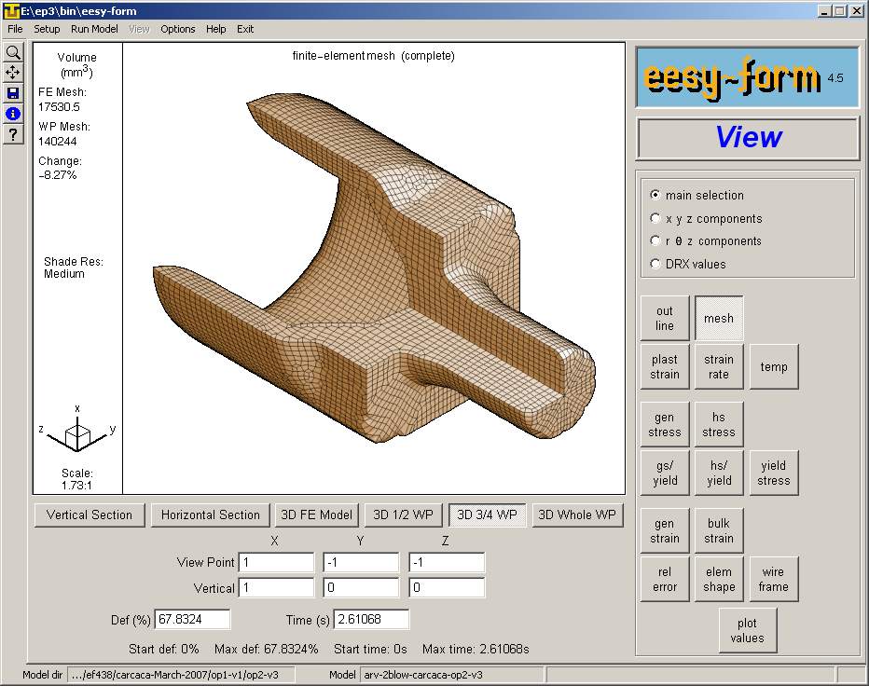
CPM GmbH starts to introduce
Version V 4.5 of the simulation system eesy-form. to the market. Together with some selected clients a test period was performed in industrial conditions.
The system is available as add-on to eesy-2-form.

eesy-form is a 3D simulation package for bulk metal forming. It simulates cold-, warm- and hot-forging operations.
eesy-form is a fully integrated system with a simple to handle user interface ment to be used by the normal industrial engineer not beeing specially trained in FEA.
The system runs on PC under Windows.
The system addresses all industries and research labs dealing with metal forming and can be used for complex process analysis and optimisation as well as for the daily process design work.

Formularbeginn
Formularende

