eesy-DieOpt
Tool layout (for multi ring die systems)
CPM GmbH offers the software- package eesy-DieOpt Version 2.04.
The software allows the tool design of single and even multi pre-stressing systems for die or punch systems. It allows considering materials, hardening, interference etc. or allows optimisation criteria such as max. possible tool load as well. All necessary data about materials and heat treatments is contained in the data base.
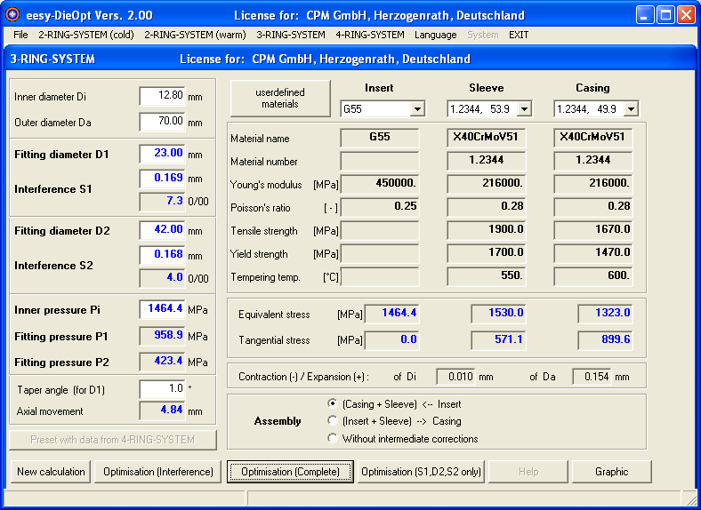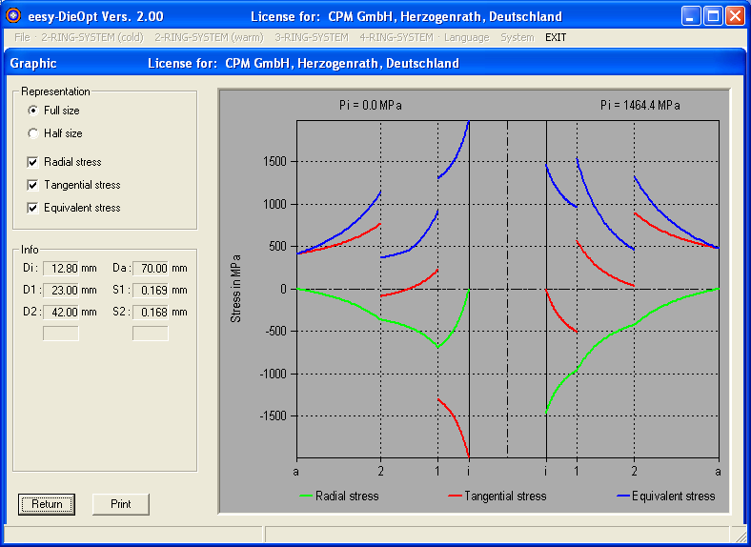
eesy-DieOpt is a software-package for layout and analysis of die and punch systems using pre-stressing rings.
It can handle simple single ring pre-stressing systems as well as two or three ring pre-stressing systems. The “normal“ industrial engineer not having special education in tool design, heat treatment etc. can handle it. This technological knowledge is built in into the system.
Besides the fast and easy to handle calculation modules (well known from literature) the system offers significant improvements in handling and algorithms compared to other design tools like FEA or data charts.
The system runs under Windows.
The system addresses all industries and research labs dealing with metal forming and can be used for complex tool layout and optimisation as well as for the daily process design work.

Formularbeginn
Formularende

