eesy-2-form

Simulation for Metal Forming
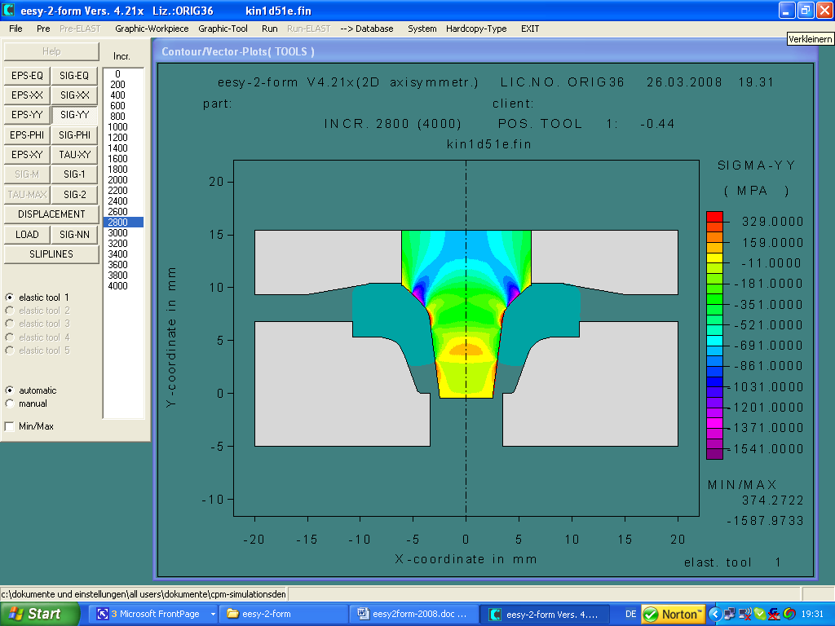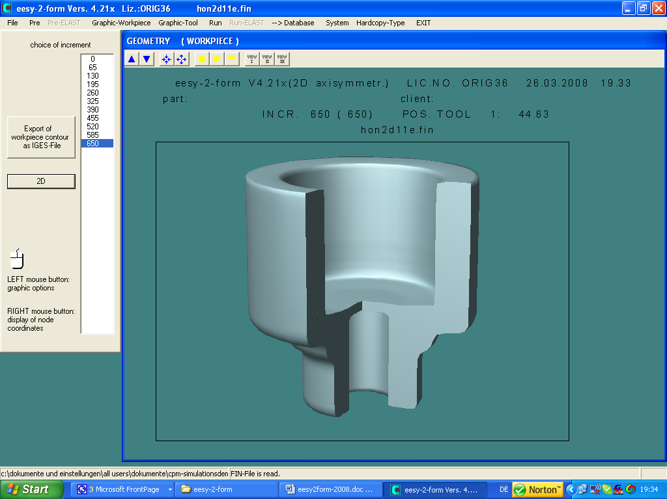
CPM GmbH offers the latest version V4.23 of the well-known simulation software eesy-2-form including elastic tool analysis. Besides the well known fast and easy to handle precise analysis of the metal forming operation and the tooling loads the system offers again significant improvements in handling and algorithmen. To mention specially is the interface to eesy-DieOpt.
The system runs under Windows.
eesy-2-form is a 2D simulation package for forging. It can handle processes in cold, warm and hot forging.
eesy-2-form is a completely integrated simulation system with an easy to handle users interface. The „normal“ industrial engineer not having special education in FEA can handle it.

The system addresses all industries and research labs dealing with metal forming and can be used for complex process analysis and optimisation as well as for the daily process design work.

